

Hang Out Activity

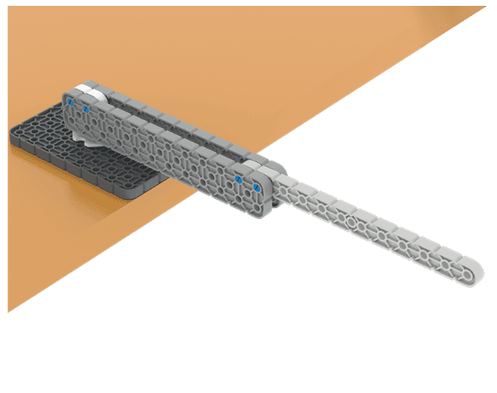 | Build a structure that reaches as far past the edge of a table as possible.

Challenge Goal: Build a structure using beams and plates from the VEX IQ Kit that extends as far off the edge of a table as possible. Make sure it does not touch the ground!

Challenge Rules:
- Use beams and plates from the VEX IQ Kit as a basis for the design, and add additional pieces as needed.
- Only pieces from the IQ Kit can be used.
- Structure length will be measured from the edge of the table to the farthest end of your structure.
- The structure must not touch the ground.

Use the Engineering Design Process
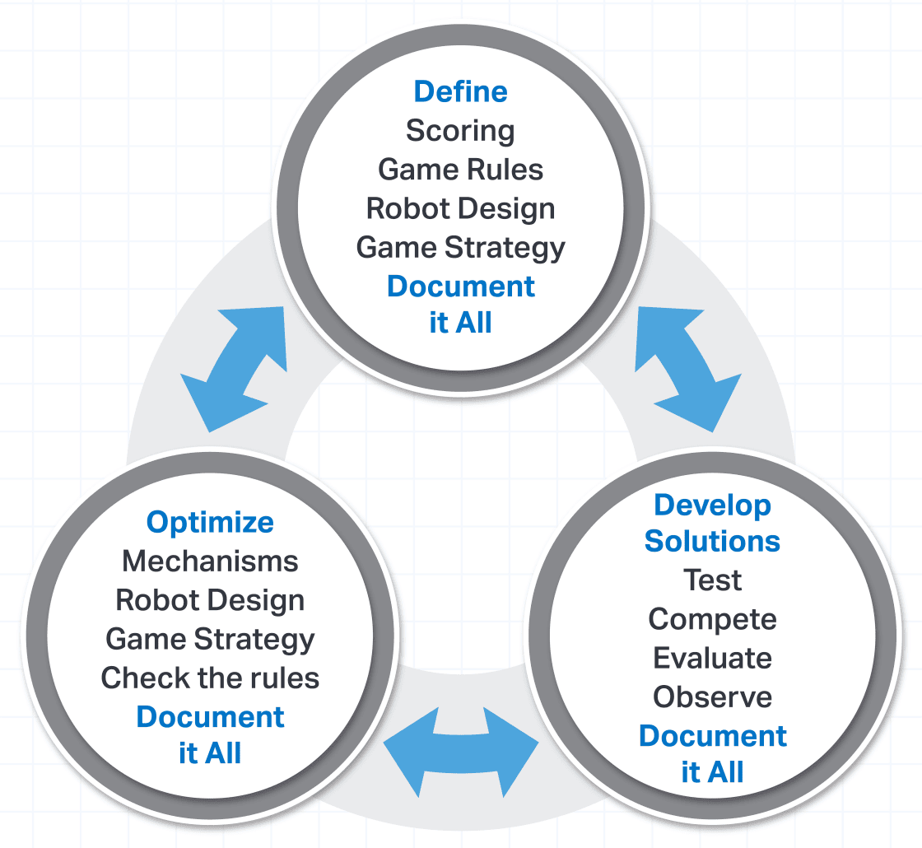 | Define  Make sure you understand the set up and rules.  Develop Solutions  Develop a plan and build your structure.  Optimize  Go on a scouting mission and improve your design.

Hang Out
Activity Notes

Hands-on time for this activity is approximately 45-60 minutes.

Preparing for the Activity

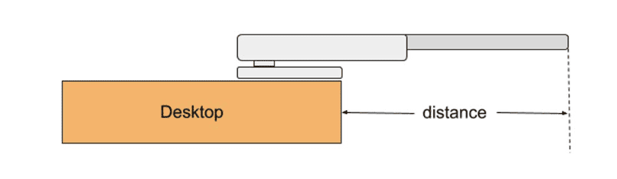
For this activity, each group will need a VEX IQ Kit. You will also need:
- A measuring tape to measure the distance each group’s structure extends off the table edge.
- A timer to keep track of build time.

Facilitating Hang Out

- Introduce the activity. Share the context here to help students connect what they will do with the robot to real-world applications.
 | The Hang Out challenge you are about to undertake seems simple: Build a device that hangs out as far as possible off the edge of the table. But small engineering decisions can make a big difference. As you plan your design, keep in mind you must use only pieces from the IQ Kit. Try to extend your device as far as possible off the table, and keep it from touching the ground or falling. This means your hang out device will need to be not just long, but also stable!  And, don’t worry if your first attempt doesn’t go as planned! You will use the Engineering Design Process to improve your project. You will develop a plan and build your structure, then test it. Then you will find ways to improve your design to make it longer and stronger.  As you work, keep in mind that the better you collaborate, the more successful your device will be. Share ideas, test often, learn from each attempt, and look for ways every team member can contribute.
- Introduce the main pieces from the IQ Kit students will need for this challenge, and how to connect them.
  - Students will need to be able to identify beams, plates, connectors and pins from the IQ Kit. Have them locate each of those pieces in the kit. See the IQ Interactive Parts Poster for help in identifying these pieces.
  - Show them how to use pins to connect two other pieces. Then demonstrate how to use the Pin Tool to pry the pieces apart and remove the pin.

- Direct students to start the Hang Out Activity.
  - Share with students that they will have 15 minutes to build. Extend or shorten this time as needed to fit your setting.
  - As students build, move around the room and talk with students, asking questions like:
    - How are you balancing the need for your device to be strong and stable, but also reach as far away from the table as possible?
    - How are you ensuring each member of your group is contributing to the project?
    - What are you using to connect your pieces? How does the number of points of connection affect your build?

- Direct students to pause and scout.
  - After students have had 15 minutes of time to build, have them pause and circulate through the room to see how other groups are approaching their build.
  - Students can ask each other questions and make observations that they can apply to improve their own builds.

- Measure each group’s structure to see how far it extends past the edge of the table.
  - Highlight the strengths of each group’s design, regardless of how far their device extends.

- Give students an additional 10 minutes to modify their designs based on what they saw during the scouting break. Be sure to measure each structure again to see how the length of each changed before and after scouting.

- Wrap Up the Activity. Refer to the Instructor Notes for details.

Extending the Activity

- Creative Constraints – Limit all groups to the same pieces in the kit (pick 2-3 categories from the IQ Interactive Parts Poster). How far can each group hang off the table using just pins, standoffs, and the other chosen categories?

- Sketch Your Designs – Students may feel like immediately building. Have them sketch out their designs and plans before beginning the building phase.

